1. **Fix the bugs in below snippet**

<html lang="en">

<head>

<title>Document

<body>

guvi

</title>

</head>

<div>

Lorem ipsum dolor sit amet consectetur adipisicing elit.

<div>

<div>

Guvi Geek Network

</div>

</body>

</html>

**Solution:**

<html lang="en">

<head>

  <title>Document</title>

  </head>

<body>

  <h1>guvi</h1>

  <div>

    Lorem ipsum dolor sit amet consectetur adipisicing elit.

      <div>

        Guvi Geek Network

      </div>

    </div>

</body>

</html>

**Output:**



1. **Try the below one**

<html lang="en">

<head>

<title>Document

<body>

guvi

</head>

<div>

Lorem ipsum dolor sit amet consectetur adipisicing elit.

<div>

<div>

Guvi Geek Network

</div>

</body>

</html>

**Solution:**

<html lang="en">

<head>

  <title>Document</title>

</head>

<body>

  guvi

  <div>

    Lorem ipsum dolor sit amet consectetur adipisicing elit.

      <div>

        Guvi Geek Network

      </div>

  </div>

</body>

</html>

**OUTPUT:**

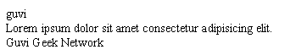

1. **Design a contact us form with all fields as required.**

**Solution:**

<!DOCTYPE html>

<html lang="en">

<head>

  <meta charset="UTF-8">

  <meta http-equiv="X-UA-Compatible" content="IE=edge">

  <meta name="viewport" content="width=device-width, initial-scale=1.0">

  <title>Contact Us Form</title>

</head>

<body>

  <div class="container">

    <form action="action_page.php">

  <fieldset style="width: 400px;">

    <legend>

      <label for="" style="font-size: 200%;"    >Contact Us</label>

    </legend>

      <label for="fname">First Name* :</label>

      <br>

      <input type="text" id="fname" name="firstname" placeholder="Enter your Firstname" required="required">

      <br><br>

      <label for="lname">Last Name* :</label>

      <br>

      <input type="text" id="lname" name="lastname" placeholder="Enter your Lastname" required="required">

       <br><br>

      <label for="email">Email* :</label>

      <br>

      <input type="email" placeholder="email" required="required">

      <br><br>

      <label for="subject">Subject* :</label>

      <br>

      <textarea id="subject" name="subject" placeholder="Write something.." style="height:100px; width: 500px;"></textarea>

      <br><br>

      <input type="submit" value="Submit" style="width: 100px; height: 50px; font-size: 20px;">

  </fieldset>

    </form>

  </div>

</body>

</html>

**OUTPUT:**

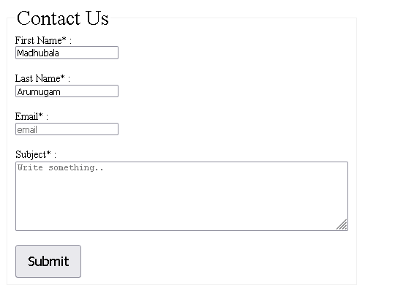

1. **Use certain HTML elements to display the following in a HTML page.**

* Programming Language
  + JavaScript
    1. Angular
    2. React
    3. Vue.js
  + Python
    1. Django Framework
    2. Flask Framework
  + Java
    1. Spring
    2. Maven
    3. Hibernate
* Database
  + MySQL
  + MongoDB
  + Cansandra

**Solution:**

<!DOCTYPE html>

<html lang="en">

<head>

  <meta charset="UTF-8">

  <meta http-equiv="X-UA-Compatible" content="IE=edge">

  <meta name="viewport" content="width=device-width, initial-scale=1.0">

  <title>List</title>

</head>

<body>

  <ul>

    <li>Programming Language</li>

    <ul>

      <li>Javascript</li>

      <ol>

        <li>Angular</li>

        <li>React</li>

        <li>Vue.js</li>

      </ol>

      <li>Python</li>

      <ol>

        <li>Django Framework</li>

        <li>Flask Framework</li>

      </ol>

      <li>Java</li>

      <ol>

        <li>Spring</li>

        <li>Maven</li>

      </ol>

    </ul>

    <li>Database</li>

    <ul>

      <li>MySQL</li>

      <li>MongoDB</li>

      <li>Cansandra</li>

    </ul>

  </ul>

</body>

</html>

**OUTPUT:**

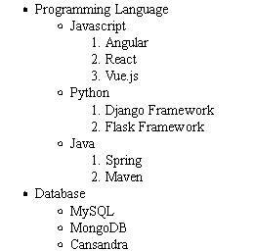

1. **Create an element that helps you to open the** [**https://google.com**](https://google.com) **in separate new tab.**

**Solution:**

<!DOCTYPE html>

<html lang="en">

<head>

  <meta charset="UTF-8">

  <meta http-equiv="X-UA-Compatible" content="IE=edge">

  <meta name="viewport" content="width=device-width, initial-scale=1.0">

  <title>Document</title>

</head>

<body>

  <a href="https://google.com" target="_blank">Google</a>

</body>

</html>

**OUTPUT:**



1. **In the form, add two radio buttons with grouping them for employee type(Salaried and own business)**

**Solution:**

<!DOCTYPE html>

<html lang="en">

<head>

  <meta charset="UTF-8">

  <meta http-equiv="X-UA-Compatible" content="IE=edge">

  <meta name="viewport" content="width=device-width, initial-scale=1.0">

  <title>Document</title>

</head>

<body>

  <form action="">

    <p>Employee Type:</p>

    <input type="radio" id="salaried" name="type" value="salaried">

    <label for="html">Salaried</label><br>

    <input type="radio" id="business" name="type" value="business">

    <label for="css">Own Business</label><br>

  </form>

</body>

</html>

**Output:**



1. **Design form shown in the link (**[**http://evc-cit.info/cit040/formguide/card_0.png**](http://evc-cit.info/cit040/formguide/card_0.png)**)**

**Solution:**

**Index.html:**

<!DOCTYPE html>

<html lang="en">

<head>

  <meta charset="UTF-8">

  <meta http-equiv="X-UA-Compatible" content="IE=edge">

  <meta name="viewport" content="width=device-width, initial-scale=1.0">

  <title>Document</title>

  <link rel="stylesheet" href="style.css">

</head>

<body>

  <form action="" id="container">

    <p id="heading">Yes! I want to subscribe to Mag-O-Zine</p>

    <input type="text" id="firstname" style="width: 200px; height: 30px;">

    <input type="text" id="lastname" style="width: 200px; height: 30px;">

    <br>

    <label for="" style="font-weight: bold; margin-left: 20px;">First Name</label>

    <label for="" style="font-weight: bold; margin-left: 182px;">Last Name</label>

    <br><br>

    <input type="text" id="address" style="width: 500px; height: 30px; margin-left: 20px;">

    <br>

    <label for="" style="font-weight: bold; margin-left: 20px;">Address</label>

    <br>

    <input type="text" id="city" style="width: 100px; height: 30px; margin-left: 20px;">

    <input type="text" id="state" style="width: 100px; height: 30px; margin-left: 60px;">

    <input type="text" id="zip" style="width: 100px; height: 30px; margin-left: 60px;">

    <br>

    <label for="" style="font-weight: bold; margin-left: 20px;">City</label>

    <label for="" style="font-weight: bold; margin-left: 140px;">State</label>

    <label for="" style="font-weight: bold; margin-left: 130px;">Zip</label>

    <p style="font-weight: bold; margin-left: 20px;">Subscribe for:

    <input type="radio" id="1year" name="type" value="salaried">

    <label for="">1 Year($19.95)</label>

    <input type="radio" id="2year" name="type" value="business">

    <label for="">2 Years($35.00)</label><br>

    </p>

    <p style="font-weight: bold; margin-left: 20px;">Send me more information about:

      <br>

    <input type="checkbox" name="details" id="computer">

    <label for="">Computer-Zine</label><br>

    <input type="checkbox" name="details" id="fishing">

    <label for="">Fishing-Zine</label><br>

    <input type="checkbox" name="details" id="cat">

    <label for="">Cat-O-Zine</label>

    </p>

  </form>

</body>

</html>

**Style.css**

body {

  border: 4px solid black;

  margin: 100px 400px;

  width: 580px;

}

#heading {

  background-color: red;

  font-weight: bold;

  font-size: 30px;

  color: white;

  width: fit-content;

  margin-left: 40px;

}

#firstname {

  margin-left: 20px;

}

#lastname {

  margin-left: 50px;

}

**Output:**

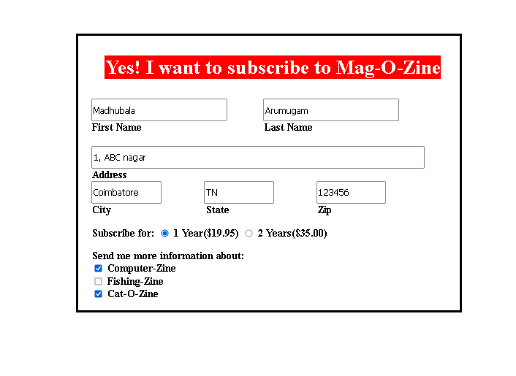

1. **Use the table tag to design given image** [**Click here**](https://www.bapugraphics.com/assets/img/port_upload_dir/table-4.jpg)**.**

**Solution:**

**Index.html:**

<!DOCTYPE html>

<html lang="en">

<head>

  <meta charset="UTF-8">

  <meta http-equiv="X-UA-Compatible" content="IE=edge">

  <meta name="viewport" content="width=device-width, initial-scale=1.0">

  <title>Table</title>

  <link rel="stylesheet" href="style.css">

</head>

<body>

  <table border="1" cellpadding="15">

    <caption style="font-weight: bold; font-size: 25px;">Health chart</caption>

    <tr>

      <th rowspan="2">State of Health</th>

      <th colspan="2">Fasting value</th>

      <th colspan="2">After Eating</th>

    </tr>

    <tr>

      <th>Minimum</th>

      <th>Maximum</th>

      <th>2Hrs after eating</th>

    </tr>

    <tr>

      <th>Healthy</th>

      <td>70</td>

      <td>100</td>

      <td>Less than 140</td>

    </tr>

    <tr>

      <th>Pre-Diabetes</th>

      <td>101</td>

      <td>126</td>

      <td>140 to 200</td>

    </tr>

    <tr>

      <th>Diabetes</th>

      <td>More than 126</td>

      <td>N/A</td>

      <td>More than 200</td>

    </tr>

  </table>

</body>

</html>

**Style.css**

td {

  text-align: center;

}

**Output:**

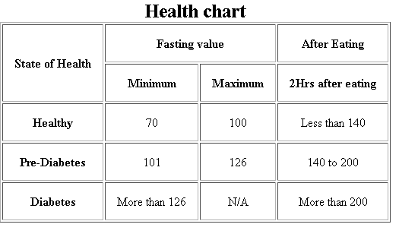

1. **Write HTML input tags snippet to show default values for all Form elements.**

**Solution:**

<!DOCTYPE html>

<html lang="en">

<head>

  <meta charset="UTF-8">

  <meta http-equiv="X-UA-Compatible" content="IE=edge">

  <meta name="viewport" content="width=device-width, initial-scale=1.0">

  <title>Form</title>

  <link rel="stylesheet" href="style.css">

</head>

<body>

  <form action="/action_page.php" style="width: 100px; height: 200px;">

    <fieldset>

      <legend>About Yourself : </legend>

      <label for="fname">First name:</label><br>

      <input type="text" id="fname" name="fname" placeholder="Firstname"><br><br>

      <label for="lname">Last name:</label><br>

      <input type="text" id="lname" name="lname" placeholder="Lastname"><br><br>

      <label for="sport">Choose a your fav sport:</label>

      <select id="sport" name="sports">

        <option value="basketball">Basket Ball</option>

        <option value="Cricket">Cricket</option>

        <option value="football">Foot Ball</option>

        <option value="tennis">Tennis</option>

      </select><br><br>

      <label for="lname">Few words about yourself :</label><br>

      <textarea name="message" rows="5" cols="30" placeholder="Write something.."></textarea><br><br><br>

      <input type="submit" value="Submit">

    </fieldset>

  </form>

  </table>

</body>

</html>

**Output:**

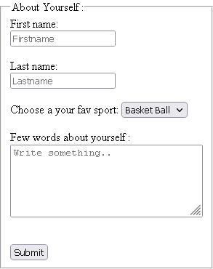

1. **In your, HTML page add the below line and Highlight it without using any CSS.**

* **"HTML & CSS is awesome"**

**Solution:**

<!DOCTYPE html>

<html lang="en">

<head>

  <meta charset="UTF-8">

  <meta http-equiv="X-UA-Compatible" content="IE=edge">

  <meta name="viewport" content="width=device-width, initial-scale=1.0">

  <title>Document</title>

  <link rel="stylesheet" href="style.css">

</head>

<body>

  <h1><mark>HTML & CSS is awesome</mark></h1>

</body>

</html>

**Output:**



1. **Create an HTML page, which should contain all types of input elements.**

**Solution:**

<!DOCTYPE html>

<html lang="en">

<head>

  <meta charset="UTF-8">

  <meta http-equiv="X-UA-Compatible" content="IE=edge">

  <meta name="viewport" content="width=device-width, initial-scale=1.0">

  <title>Input tags</title>

  <link rel="stylesheet" href="style.css">

</head>

<body>

      Button :

      <input type="button" value="Button"><br><br>

      Checkbox :

      <input type="checkbox"><br><br>

      Date :

      <input type="date"> <br><br>

      Input text :

      <input type="text"><br><br>

      Email :

      <input type="email"> <br><br>

      Upload File :

      <input type="file"><br><br>

      For numbers :

      <input type="number"><br><br>

      Password :

      <input type="password"><br><br>

      Radio button :

      <input type="radio"><br><br>

      Slider :

      <input type="range"><br><br>

      Reset button :

      <input type="reset"><br><br>

      Submit button :

      <input type="submit" value="Submit"> <br><br>

      Time display :

      <input type="time" value="10"><br><br>

</body>

</html>

**Output:**

